G4 Temperature tag (Orion)
Flashing steps
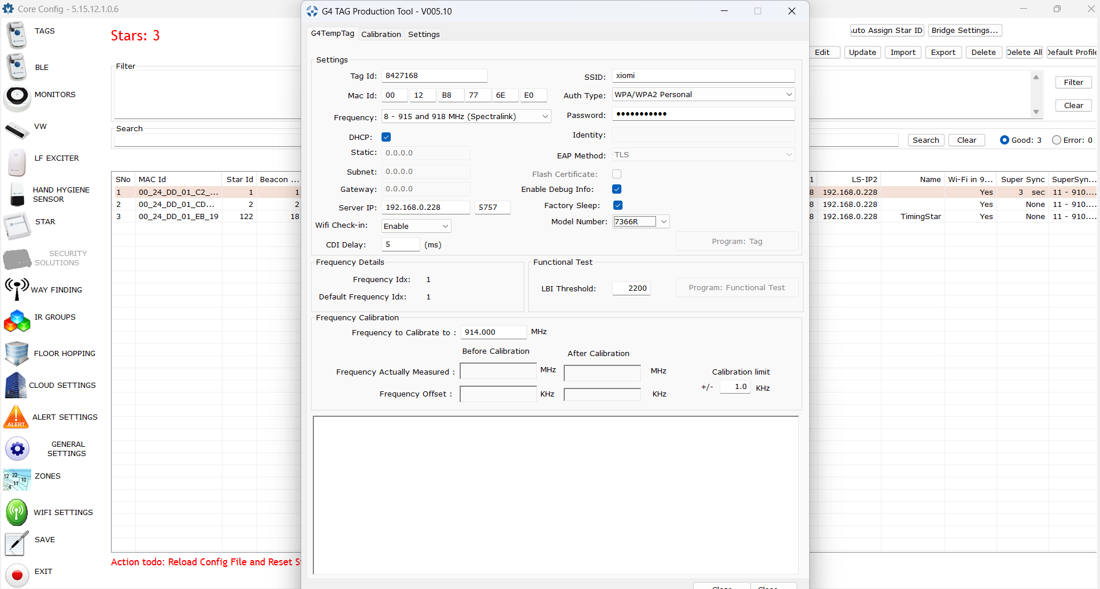
SSID and Password need to use from ur local wifi router setup
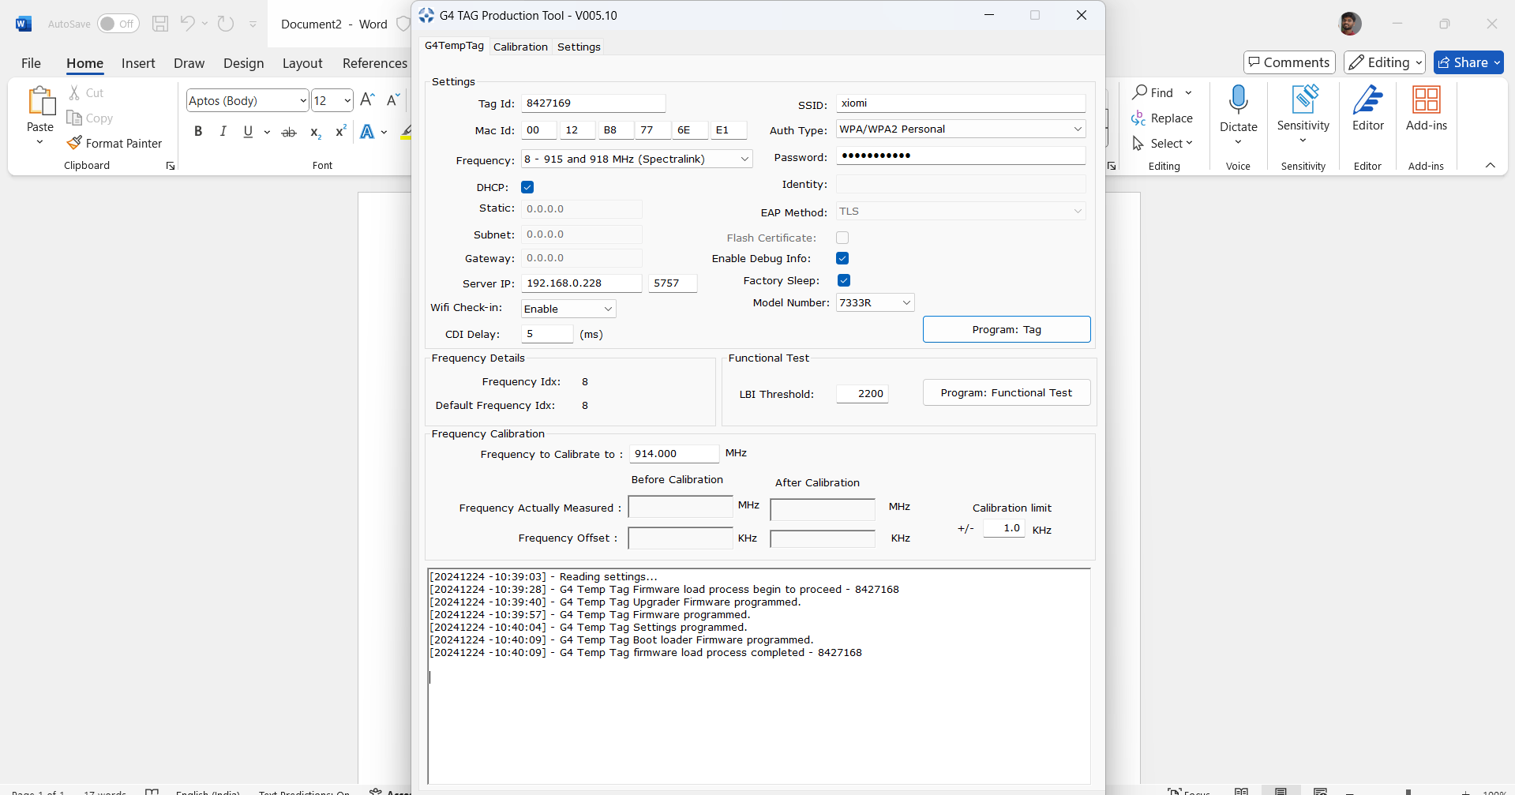

If model number is 7333 then it uses internal sensor and if it uses 7366 then it uses external sensor probes, based on this we need to select the tags in Core config tool in Environmental monitoring devices section

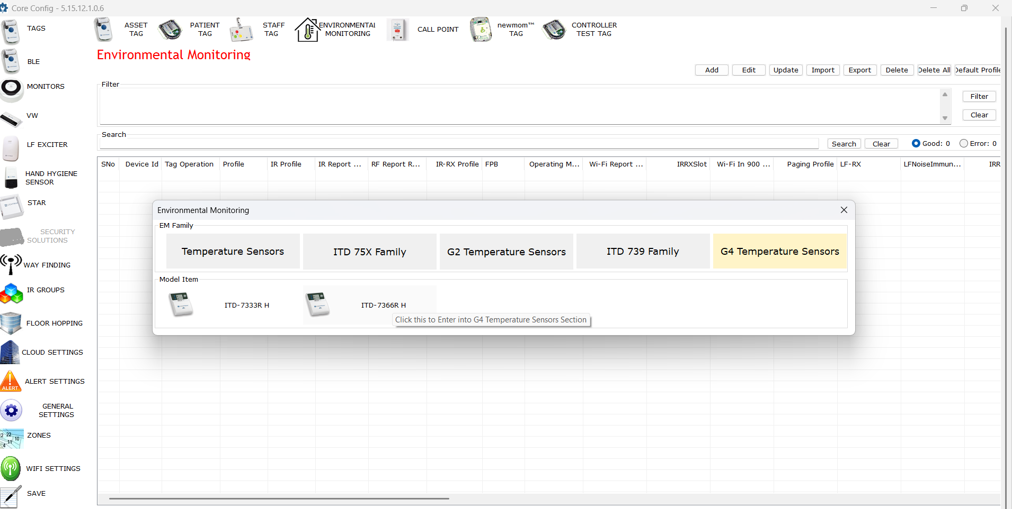

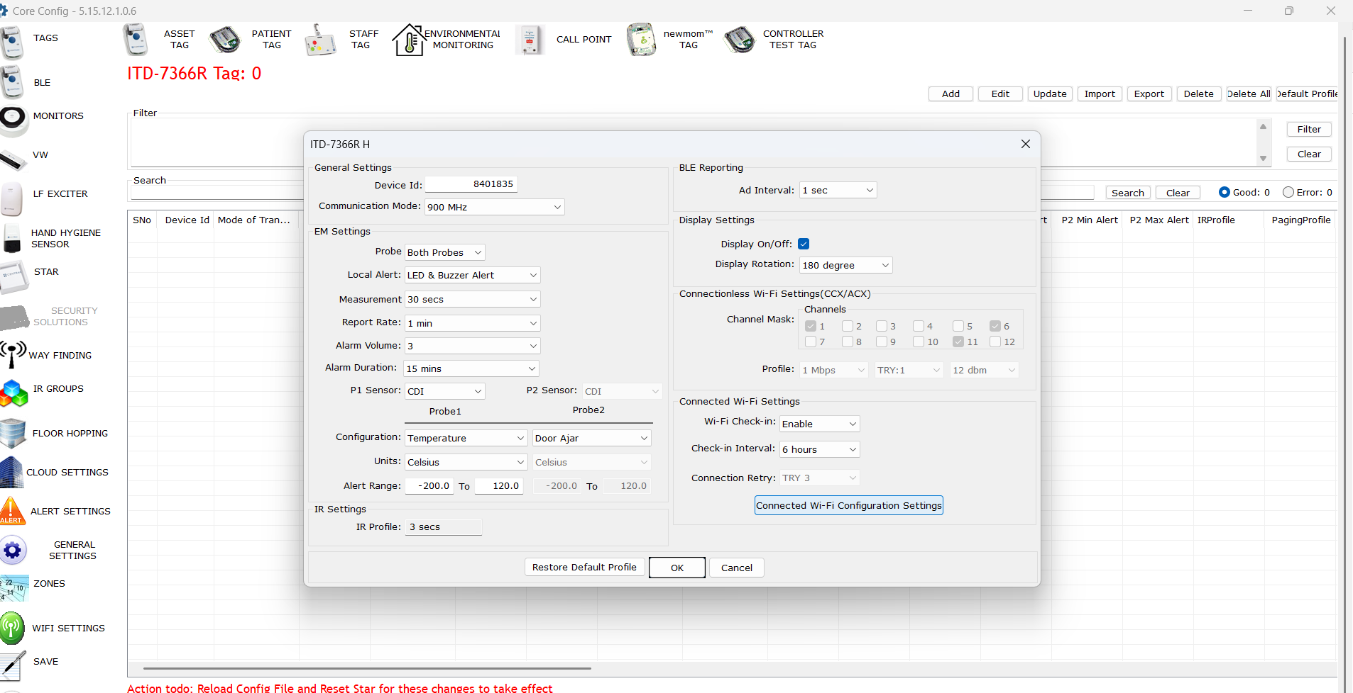

Communication mode can be configured to four different modes

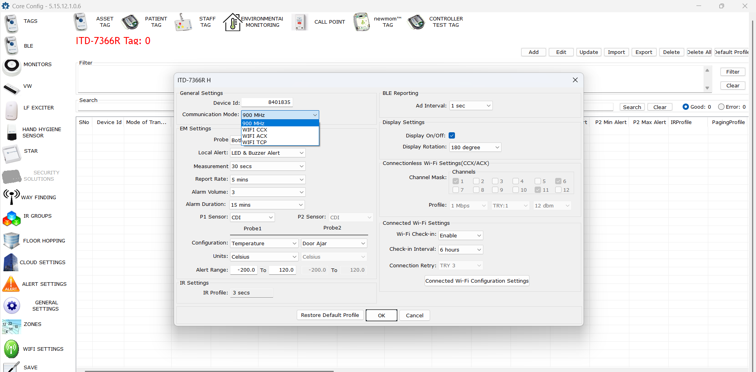

For door closed scenario tag will update immediately within 15 secs, but for door open tag will update the status after three measurements i.e after 45 secs (Each measurement takes 15 secs)
Temperature or Door open/close will be indicated in Temp1/Temp2 field of Corelive

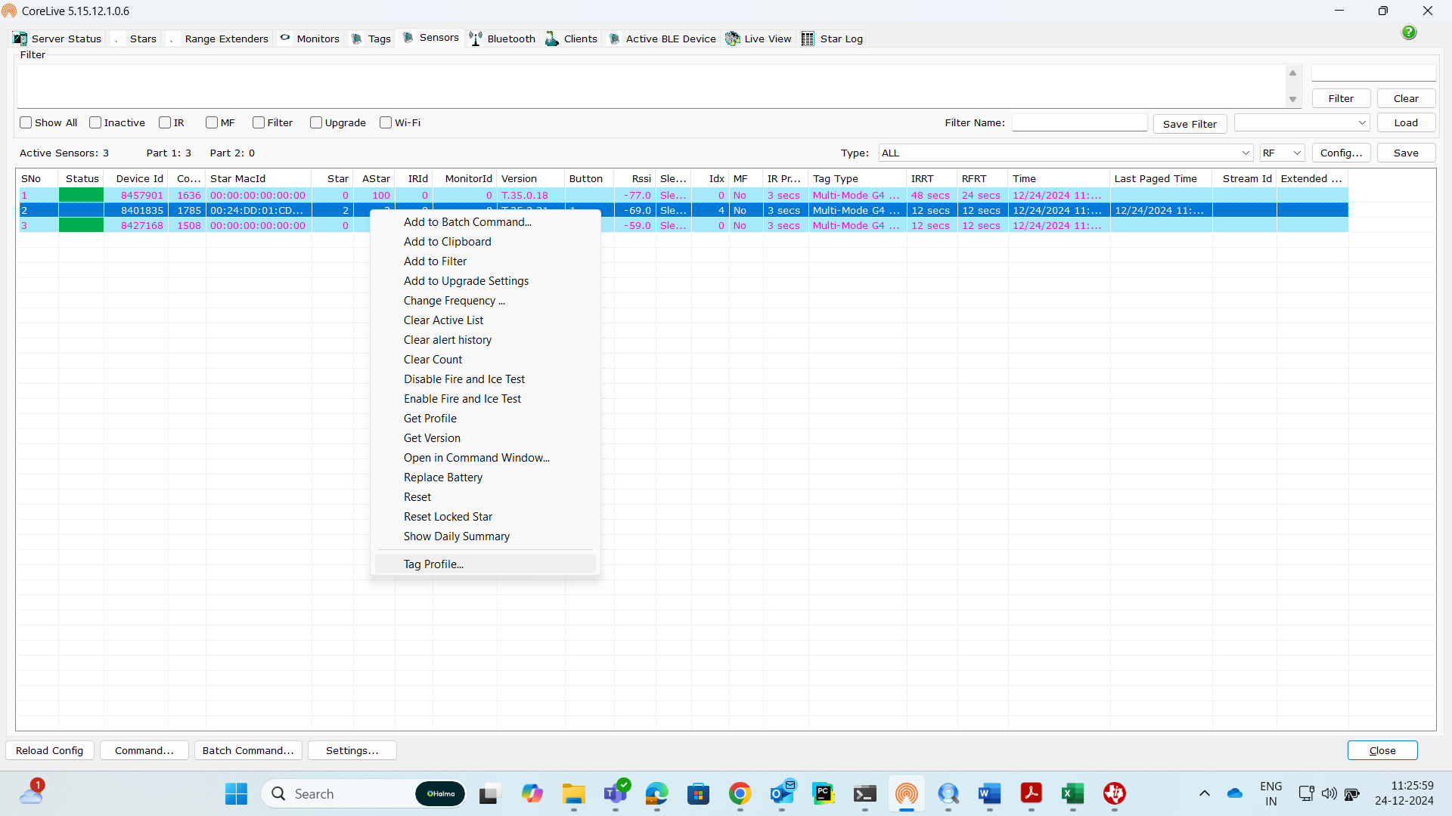
Right click on tag and goto tag profile to edit the tag configs and range for temperature reporting

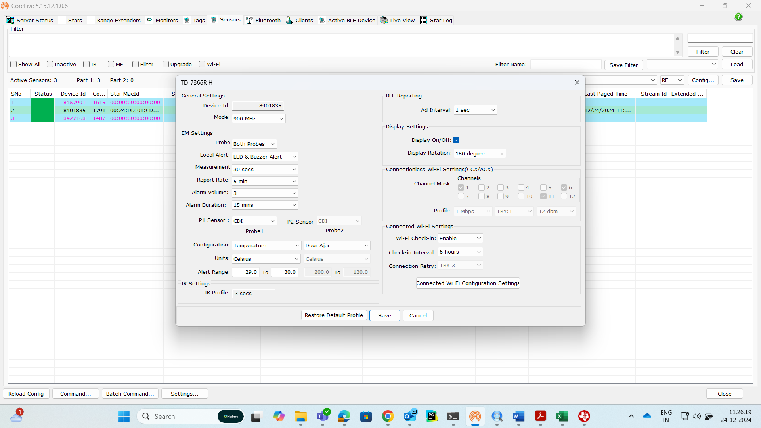

Setting communication mode to CCX

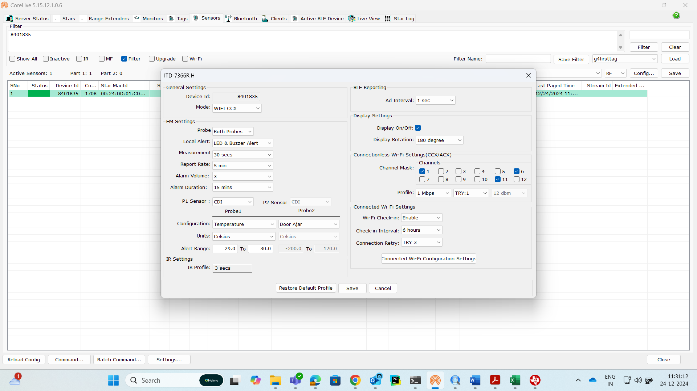

With Communication mode as ACX
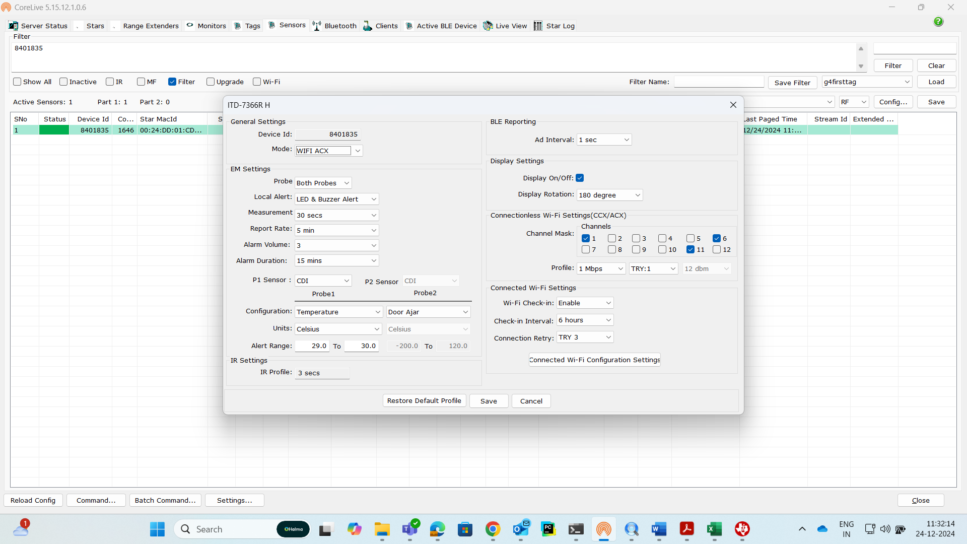
Communication mode as WIFI TCP
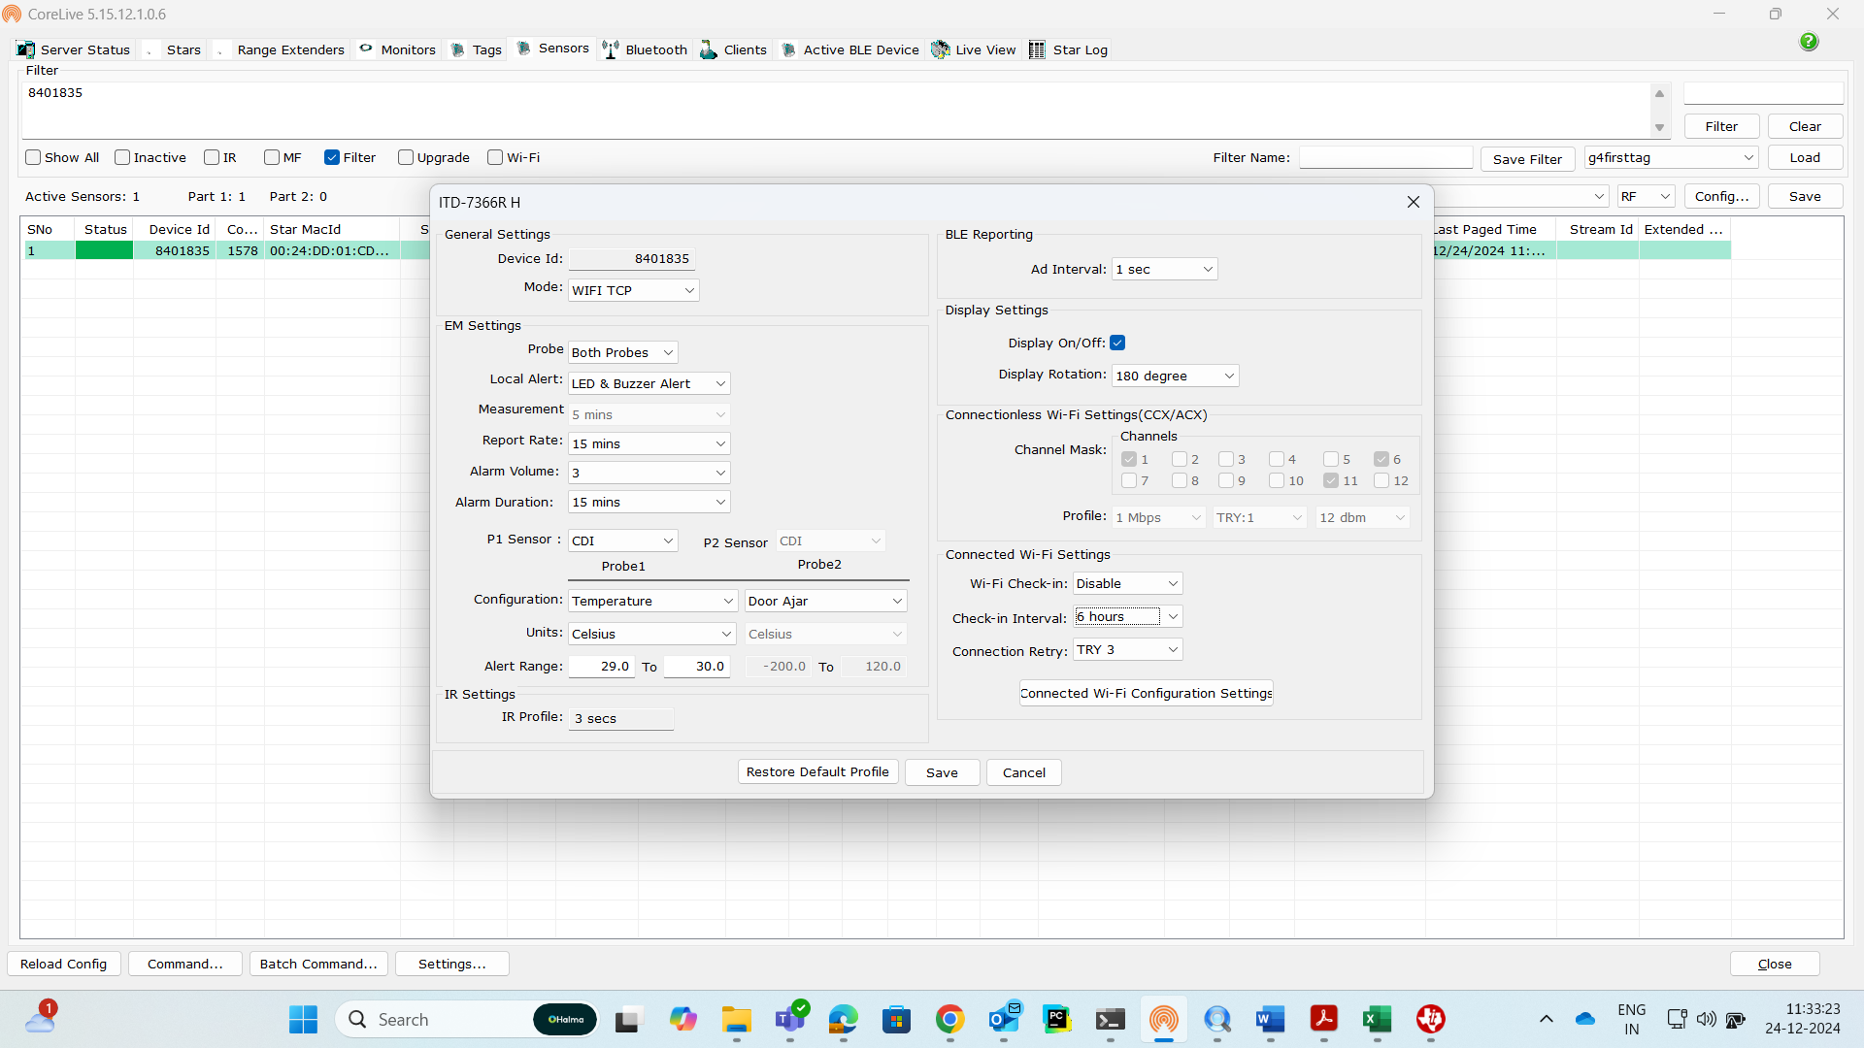

To simulate tag not in star coverage
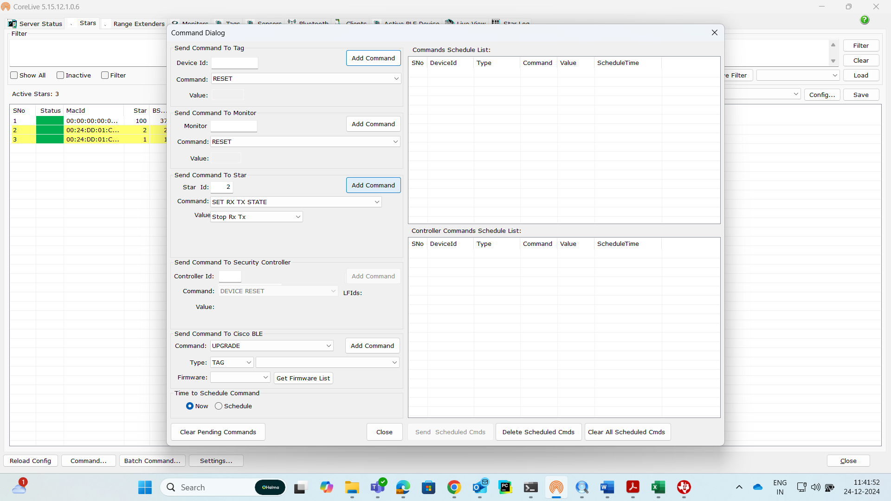
After 15 min star will roll back to normal mode by changing from “Set RX TX” state to Allow All state
If we want to keep tag in no star coverage area, then we must set “Set Tx Rx” option to Allow Paging Rx

GDD (Guaranteed data delivery)
G4 tags will store total of 8640 temp values if it is disconnected from star
Once it connects to star tag starts pushing the data one after the other with an interval of 3 secs
GDD (Guaranteed data delivery) will get cleared when report rate is changed, or Probe selection config is changed (Temp to Door or Door to Temp)
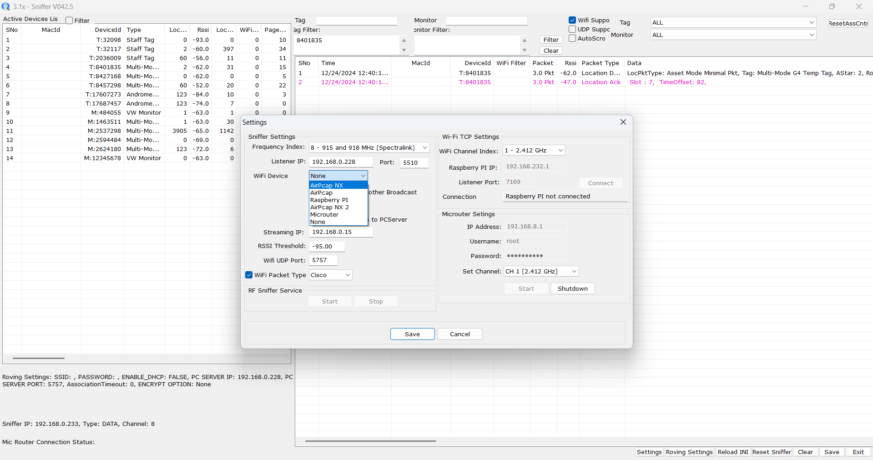
Streaming IP should be the IP where server is configured when data is captured via AirPcap NX dongle

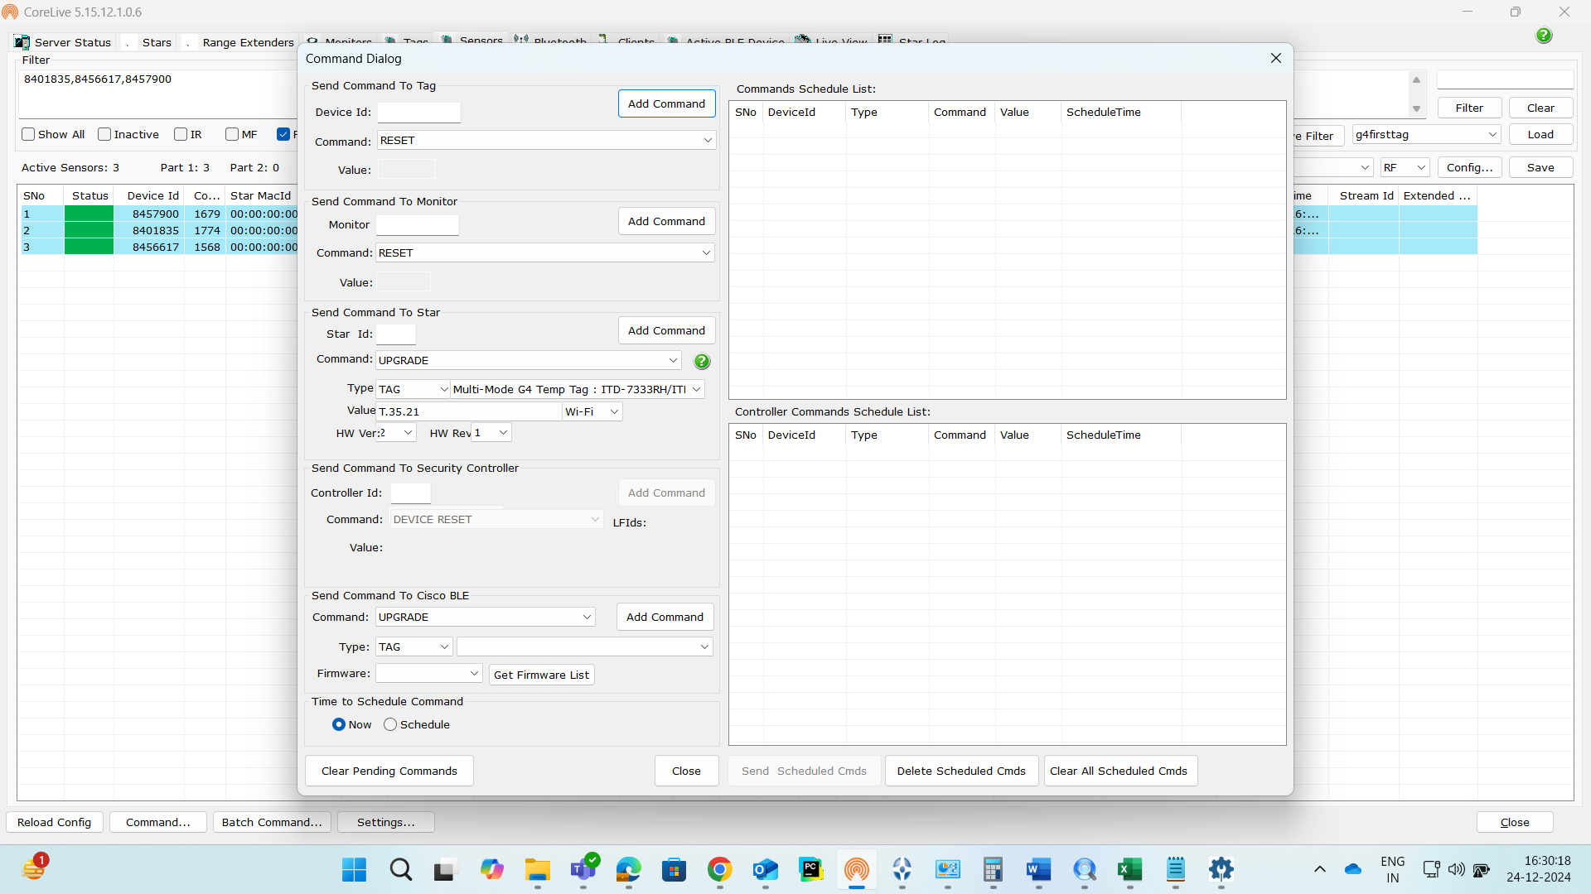

Analysing WIFI OTA packets in activity monitor tool
Below is the OTA start packets
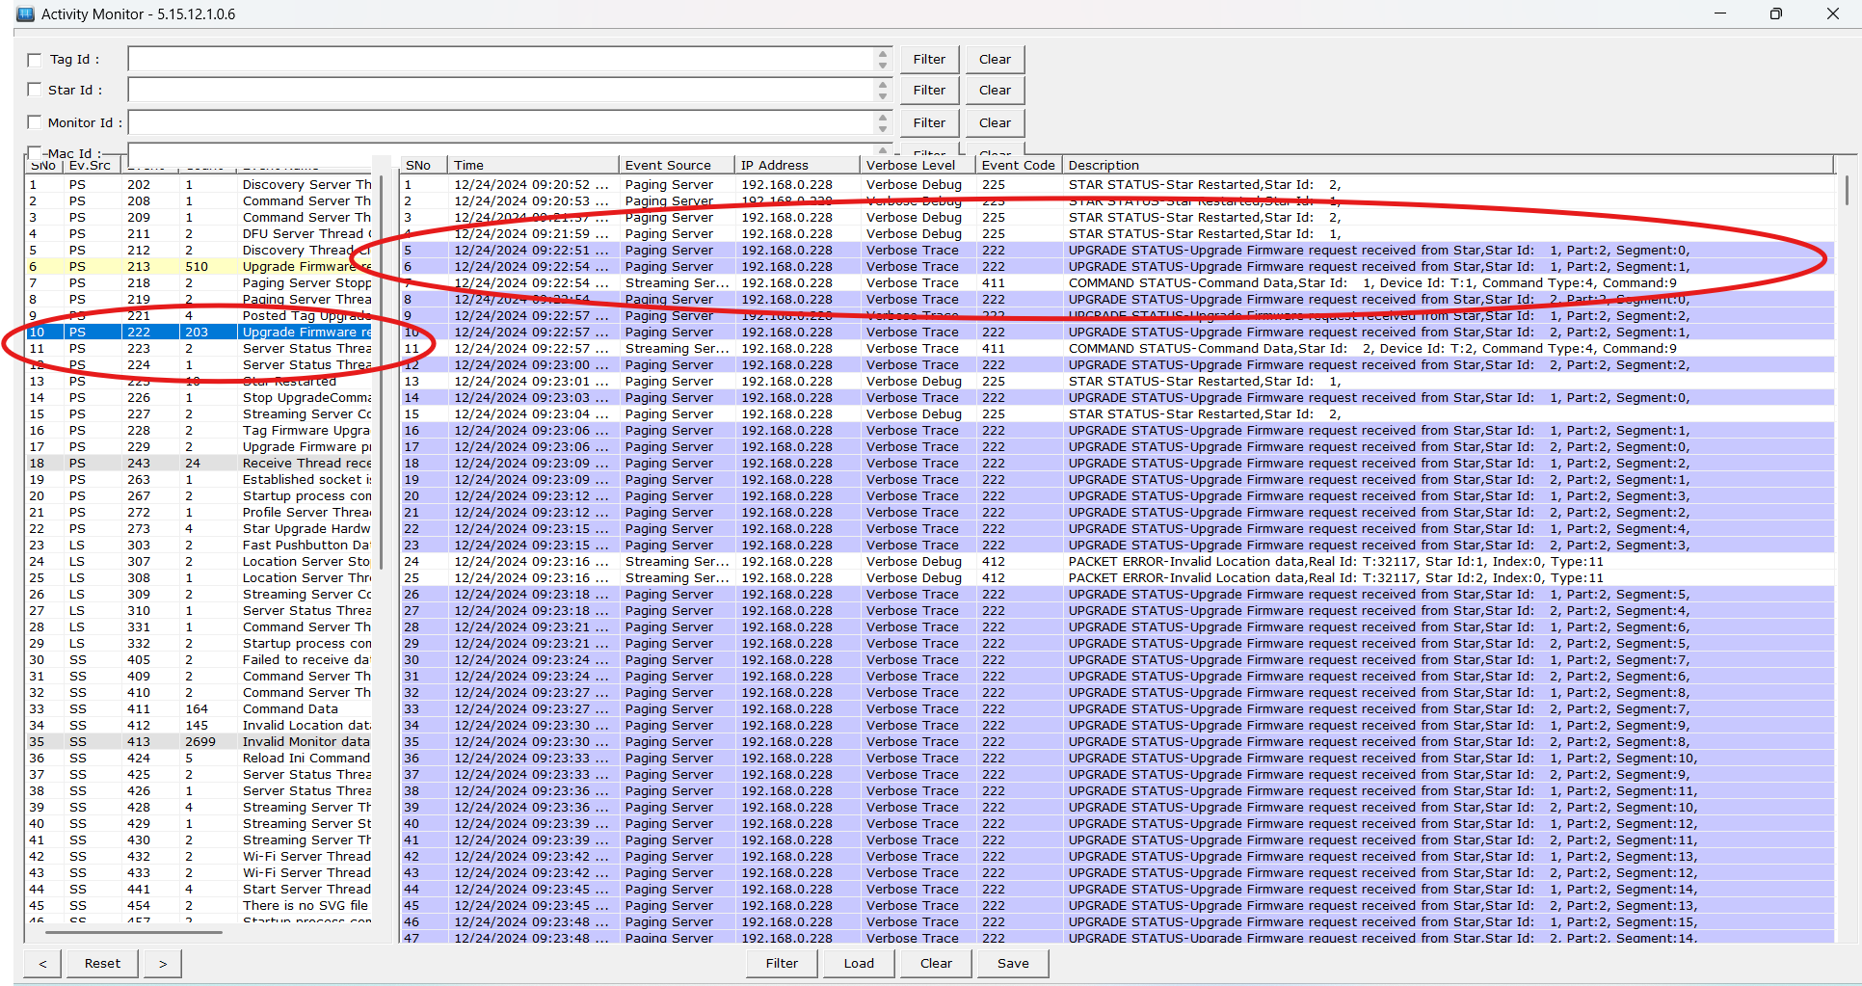
Below is the status after OTA completion
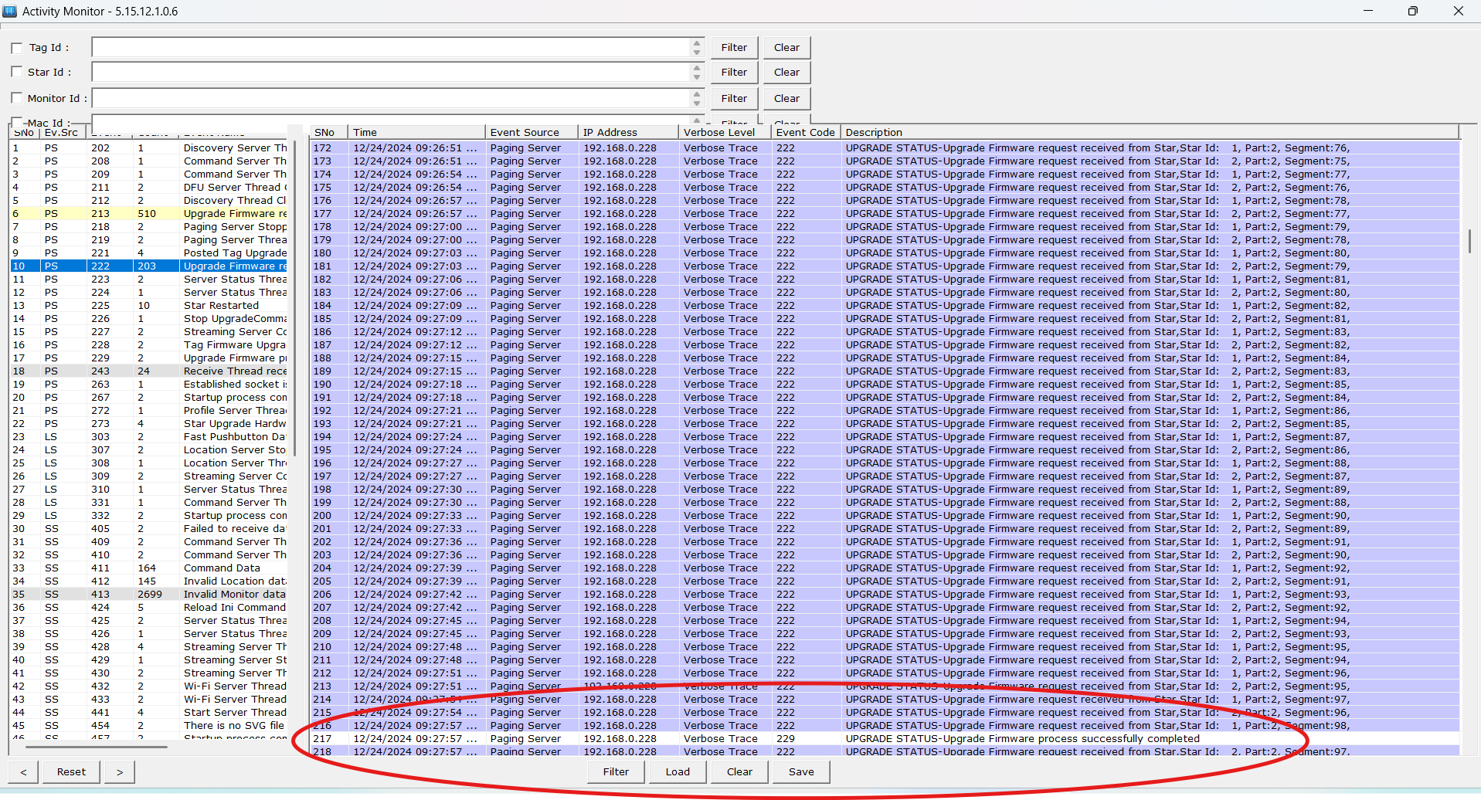

GDD Tool usage
Probe 1 is for Temperature and probe 2 is for Humidity sensor (Both are configurable in Tag profile configuration, we can interchange them)
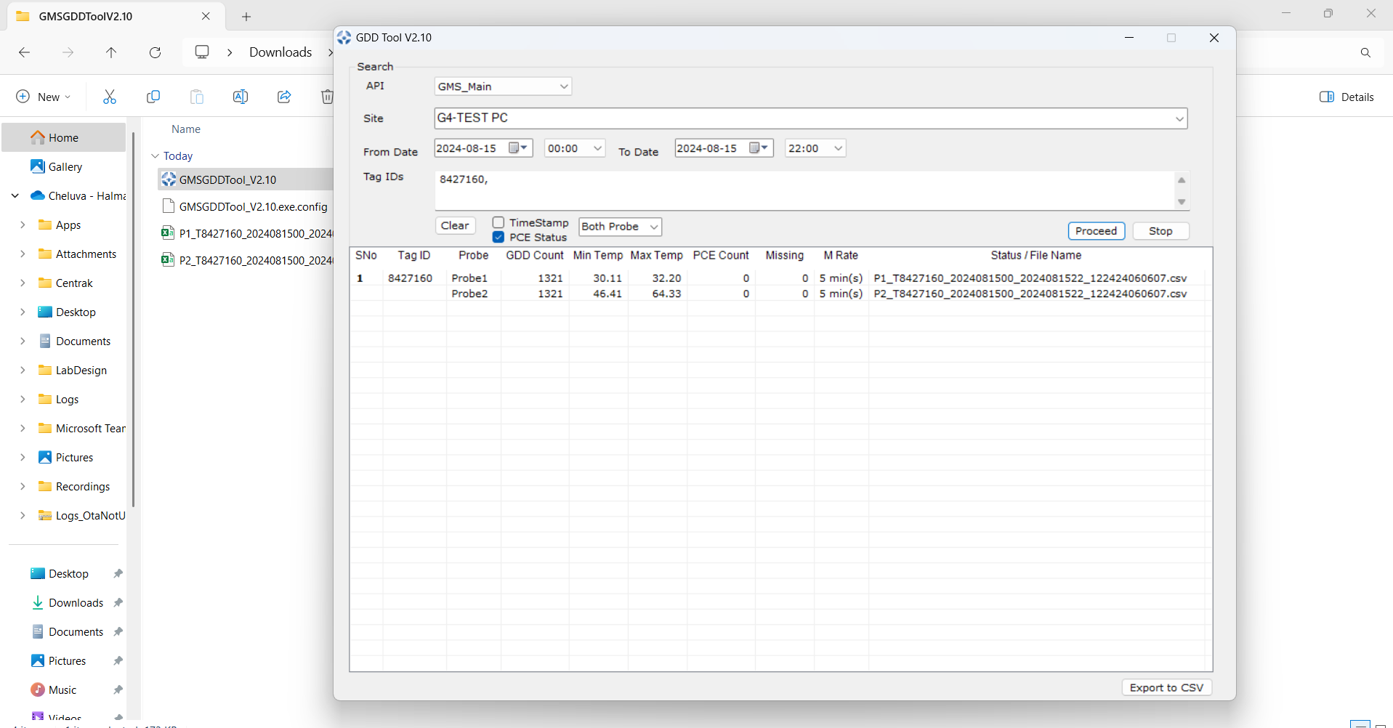
Using Microuter dongle for Wifi sniffing
Just connect the Microuter dongle and run OpenPcap tool from sniffer tool folder and wait till dongle changes to ready state then click on Start option
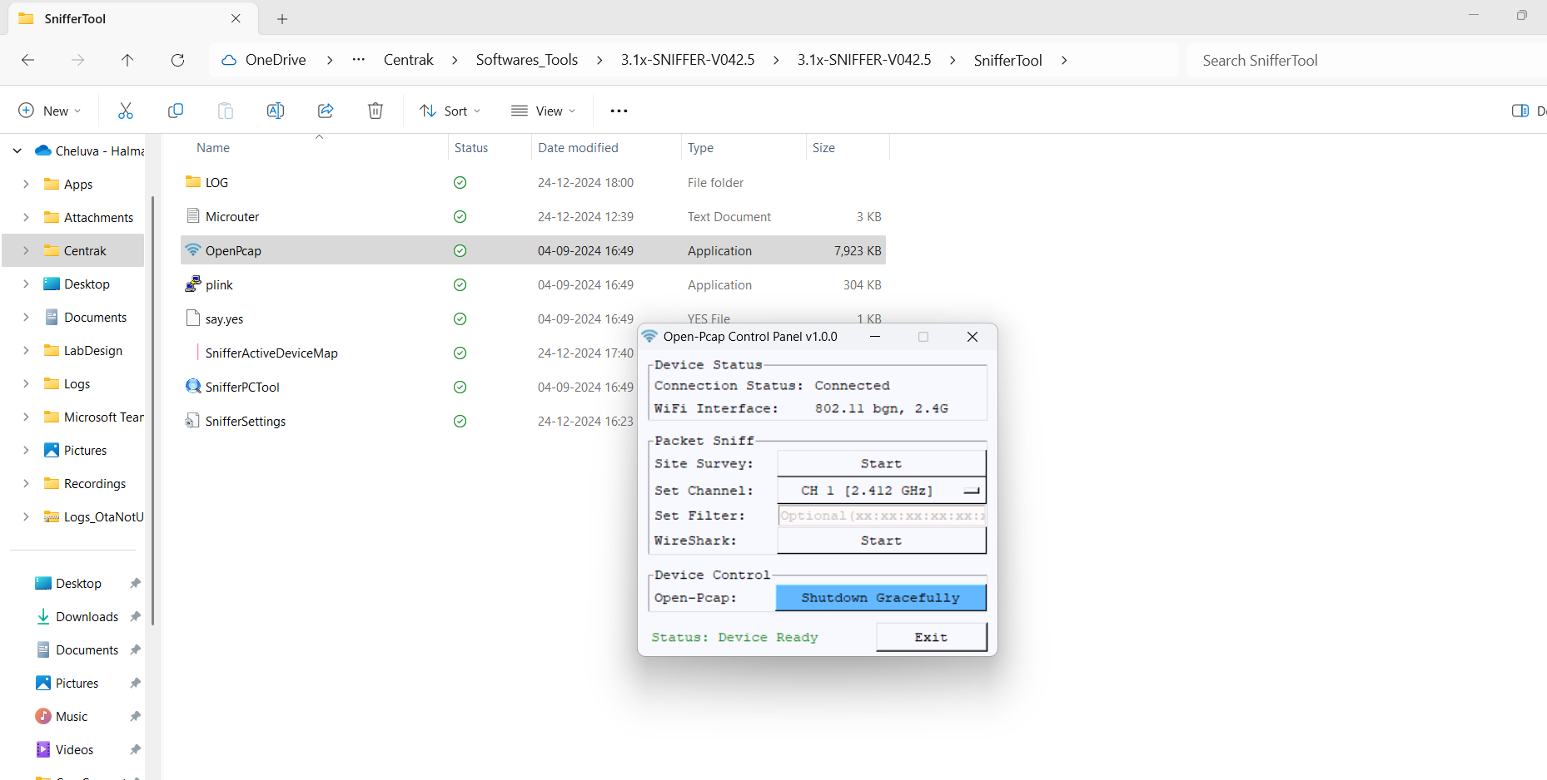

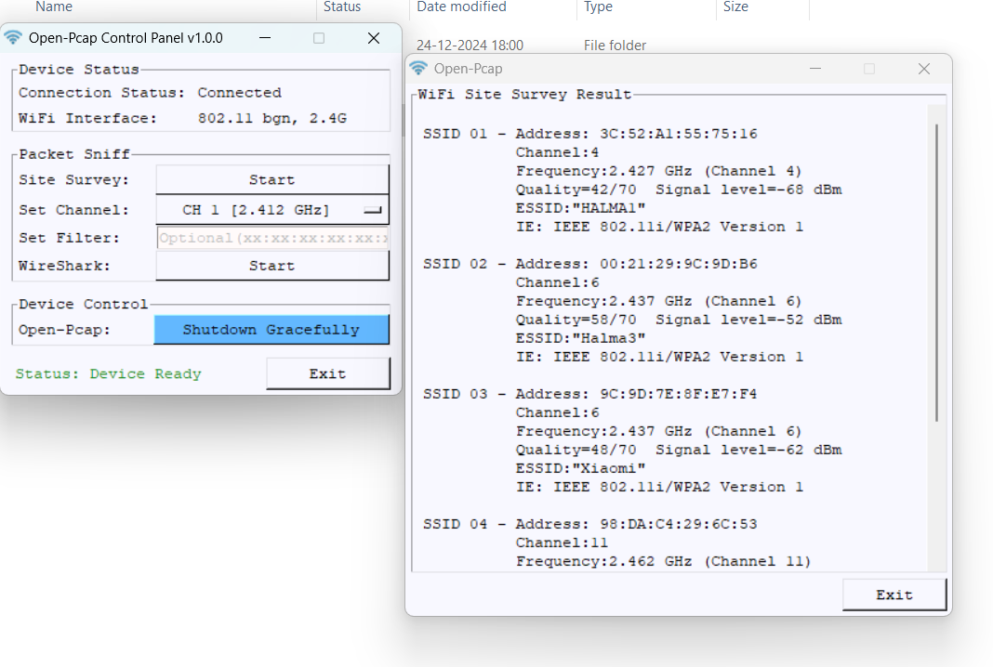

From settings option on Sniffer tool select Microuter and click on Save, click start option
